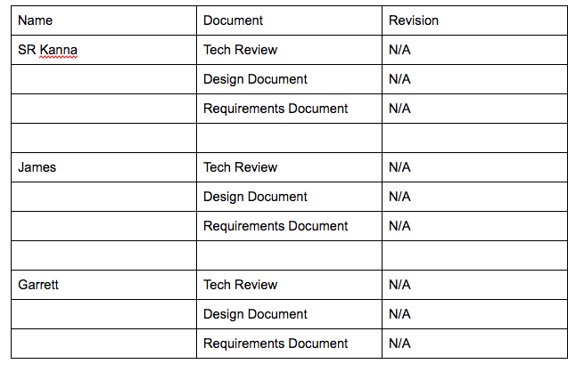

We were individually in charge of several features including CSS, login, security, gantt chart, time-in/time-out, database etc. The only major change that we need to think about is how we are not implementing our own database and hosting in public html instead of using their database or server, but none of our documents have said anything explicit about this. We would like to further meet with the clients, TA and professors before making changes.